
Component Model
Control APIs
Robotic Cognition System for Wheelchair
Unicamp

Table of Contents
1 Purpose of this Document 3
2 Component Design 4
2.1 Purpose 4
2.2 System Diagram 4
2.3 Component Input 4
2.4 Component Output 4
2.5 Component Processing 4
3 Component Execution 6
4 References 10

Document Information
Project Name: | Robotic Cognition System for Wheelchair
Prepared By: | Tarcísio Franco de Carvalho | Document Version No: | 1.0
Title: | Component Model – Control APIs | Document Version Date: | 29/Sep/2020
Reviewed By: |  | Review Date:
Distribution List
From | Date | Email

Acronyms
Acronym | Description
ROS | Robot Operational System
API | Application Programming Interface

Document Version History
Version  Number | Version  Date | Revised By | Description
1.0 | 29/Sep/2020 | Tarcisio | Initial Version

Purpose of this Document
Define how the related component works and its relation in the main system.

Component Design

Purpose
This component gets UPD data from current environment and the current laser pointer data parsed to point cloud and verifies if the laser is pointing to point cloud in UPD that are safe or not to be passed considering the current robot configuration.

System Diagram
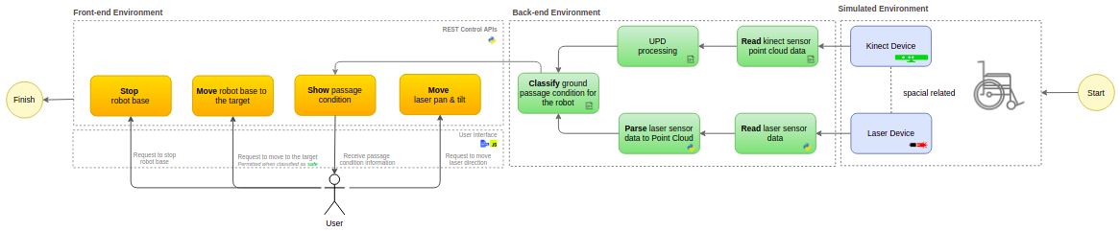

Component Input
This component reads the ROS node “/upd_point_cloud_classification” that publishes the open transversability data from depth camera point cloud, the “/laser/point_cloud” node that publishes the parsed laser data to point cloud, and the “/joint_states” node that publishes the laser pan and tilt position.

Component Output
This component publishes the passage classified as safe or unsafe string on ROS node “passage_condition”. This output will be showed as a service in a HTTP REST API, to be an interface for a UI as Web Page, Mobile Application, etc.

Component Processing
This component reads the laser data and parse and publisher its as point cloud data in a ROS node. The diagram below shows this relationship:

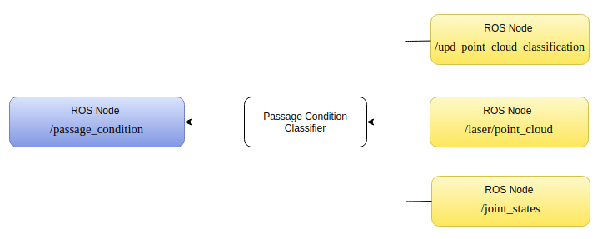

Below the main process flow for this component that occurs in cycles:

- Load the UPD (open transversability) data
- Load the laser point cloud data
- Load laser pan and tilt values
- Load setup parameters
  - Laser Frame axis x, y and z to depth camera device frame
  - Vox Grid Leaf x, y and z
  - Heuristic percentage for number of green points to the passage be considered safe
- Transform laser point cloud data
  - Translate the laser frame to depth camera device frame
  - Rotate the laser frame in z axis for the current pan value
  - Rotate the laser frame in y axis for the current tilt value
- Defining the kdtree and the point object for the search
- Load the UPD cloud to kdtree object
- Iterate the laser points and search them on UPD cloud using kdtree algorithm
- Determine the passage condition
- Publish the passage condition

Source code on GitHub:
https://github.com/tarcisiofcarvalho/robot_cognition_system/blob/master/src/passage_classifier_publisher.cpp

Component Execution

To execute this component is necessary the Gazebo simulation environment, ROS main process running and the Rviz tool to show processed data. Bellow the steps to run this component:

- Start Gazebo environment simulation
On the project root folder, run the script ./sim_model/scripts/launch.sh it will process the simple_blocks.world and sim_model.urdf.xacro files

Result
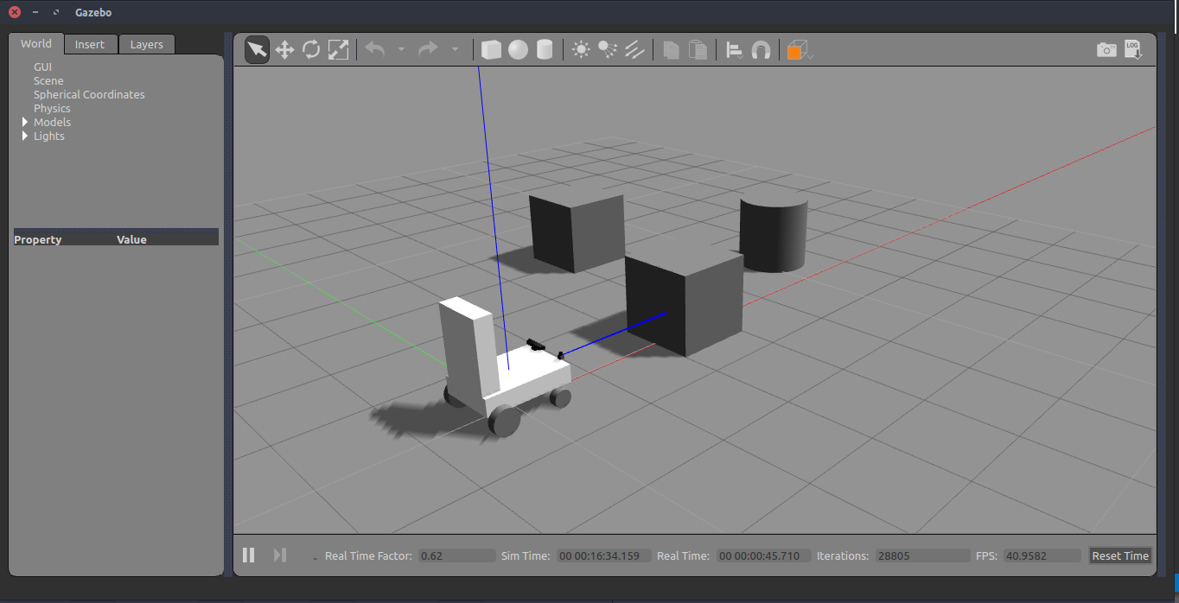

- Start web user interface to control the laser

On the project root folder, run the script python src/web_app.py it will start the flask web server and a web page where the laser can be controlled. After starting, in a web browser open the http://localhost:8080

Result
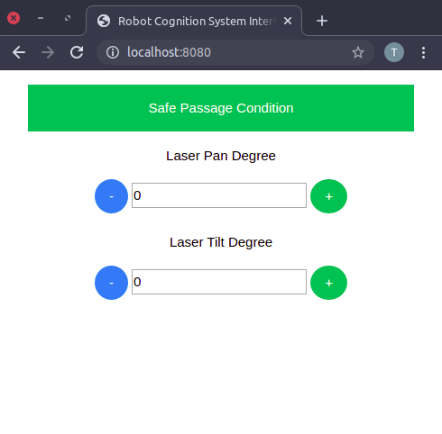

- Start the laser sensor data to point cloud parser component

On the project root folder, run the script python src/laser_publisher.py it will start a node to published parsed laser data.

Result
In the Rviz the red points are the parsed laser data
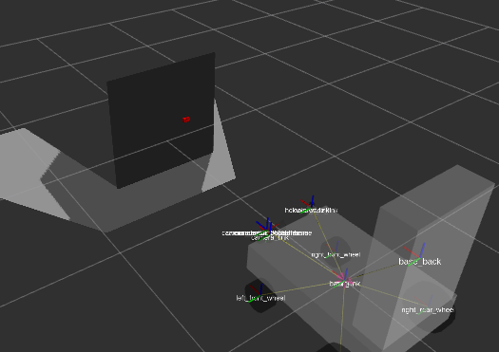

- Start the UPD processing component

On the project root folder, run the script ./upd_run.sh it will start a node to published UPD data

Result
In Rviz the UPD data is being showing.

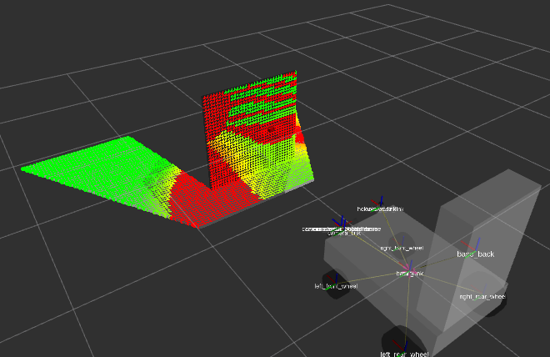

- Start the Classify passage condition component

On the project root folder, run the script ./classifier_run.sh it will start a node to publish passage condition classified data

Result
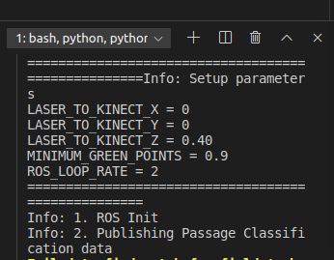

- Move the laser direction to a safe passage condition
In the UI, move the laser pan and tilt to reach red UPD classified points cloud in Rviz, then verify if the box message color in UI will change to red.

Result

- Before
Simulation | Rviz | UI
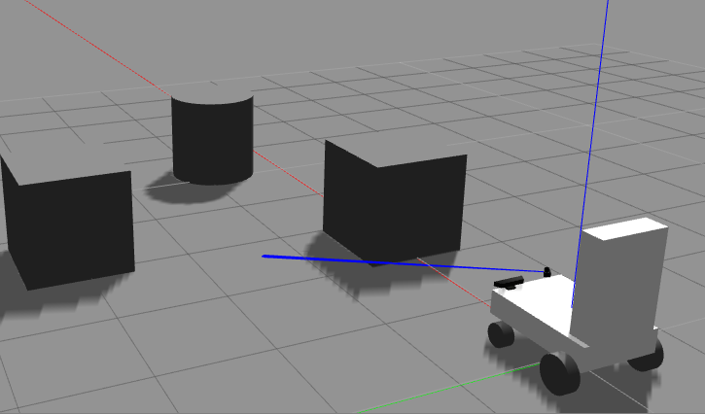
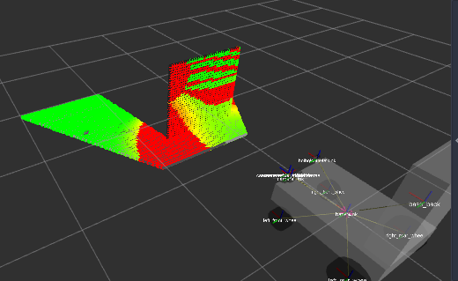
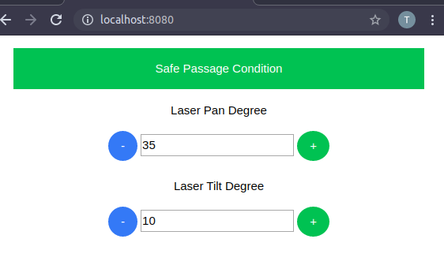

- After
Simulation | Rviz | UI
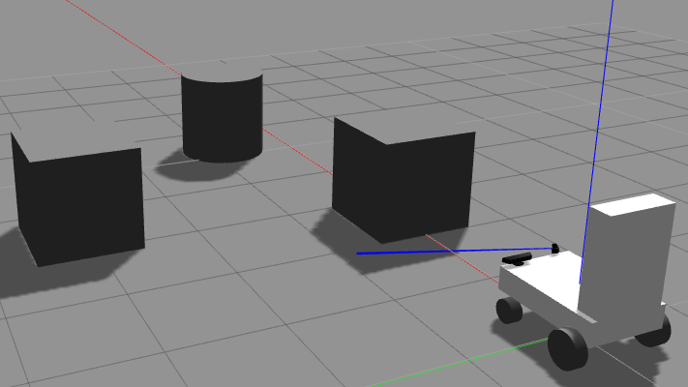
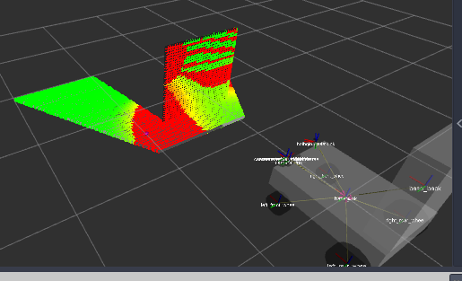
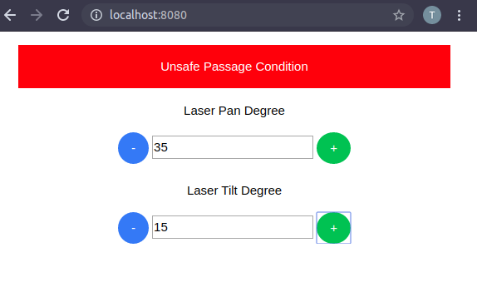

References

- Point Cloud
  - Accurate laser scanner to camera calibration with application to range sensor evaluation: https://link.springer.com/article/10.1186/s41074-017-0032-5
- ROS & Gazebo
  - Control: http://wiki.ros.org/ros_control
  - ROS and Gazebo Tutorial: http://wiki.ros.org/action/fullsearch/urdf/Tutorials/Using%20a%20URDF%20in%20Gazebo?action=fullsearch&context=180&value=linkto%3A%22urdf%2FTutorials%2FUsing+a+URDF+in+Gazebo%22
  - Pan & Tilt Gazebo Simulation: https://www.theconstructsim.com/pan-tilt-gazebo-simulation
  - Gazebo Joint Controller: http://gazebosim.org/tutorials/?tut=ros_control
- Others
  - Rotation Matrix: https://en.wikipedia.org/wiki/Rotation_matrix
  - Rotating project point: http://www.pcl-users.org/Rotating-projected-point-cloud-to-get-z-0-for-all-points-td4034031i20.html
  - C++ Eigen Matrix: https://eigen.tuxfamily.org/dox/group__TutorialMatrixClass.html

